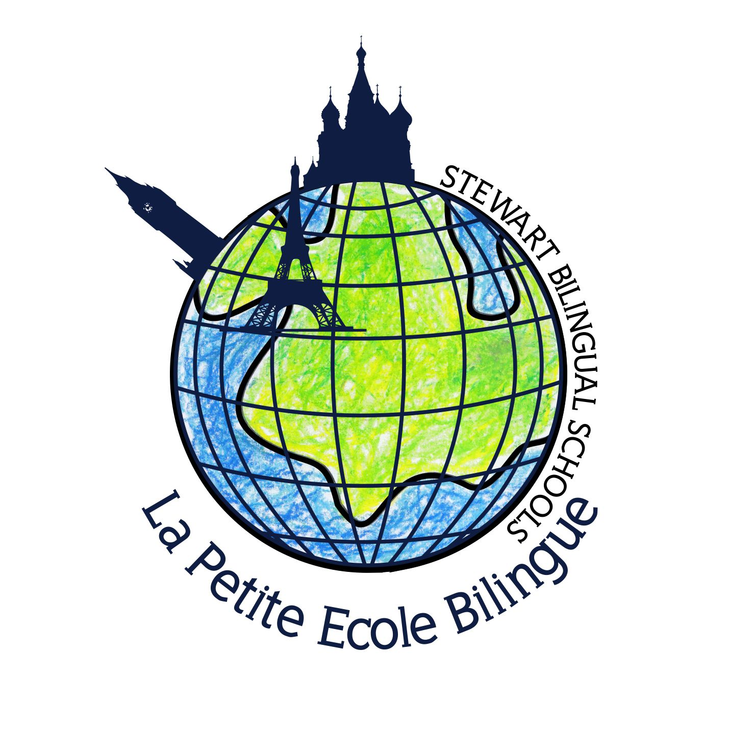

La Petite ecole Bilingue

Parents’ Information Guide 2018 – 2019

Part two

Contents
A word from the head teacher 2
Dual Curriculum Error! Bookmark not defined.
Communications Error! Bookmark not defined.
Communication books Error! Bookmark not defined.
Class Organisation Error! Bookmark not defined.
Snacks Error! Bookmark not defined.
Monitoring progress 3
Assessment 3
Special Educational Needs and disabilities. 4
Homework 4
Reading Guidance 6
Phonics 6
French Alphabet vs. Sounds Error! Bookmark not defined.
Mathematics 8
Marking 9
Science Error! Bookmark not defined.

A word from the head teacher

This document has been written to provide parents with a brief outline of the areas the children will be working on over the course of the academic year and our aims in each subject. We review and develop our curriculum at all times so the information enclosed may alter slightly.

A welcome letter is sent at the start of the year as well as later a weekly newsletter, which will highlight any changes to the class timetable, projects, planned trips and requirements, as well as, descriptions of expected uniforms to be worn at school.

We are thrilled this year to welcome new members of staff to our team of teachers and I am sure that when you look back in July you will be delighted with the amount of progress your child has made in all aspects of school life.

The children grow in confidence and independence and respond well to the more formal nature of their curriculum and timetable.
I hope that you find this guide both interesting and informative and use it to support your child’s learning at home.

I wish you and your child a happy and fulfilling year.

Dr Helene Knupffer, PhD
Head Teacher.

Monitoring progress
Every child’s progressed is carefully monitored and recorded by the Teacher working with the deputy head, Miss Blunden. Progress reviews will involve coordinators and appropriate members of the senior management team (Mrs Helene Knupffer, Head teacher and Safeguarding Officer, Miss Blunden as Deputy Head, Mrs Tracey Martin, in her role as SENco and Miss McLaughlin as EYFS coordinator.) Relevant teachers will contribute to these assessment reviews.

How do we assess pupils ‘progress?

The National Curriculum is broken down into statements and objectives, which show what pupils should be achieving over each academic year. Teachers also pull statements from the interim assessment frameworks. The statements are transferred onto grids, using our scholarpack software.
Teachers highlight statements on the grids whenever they see evidence the pupil is achieving them. Evidence comes from:
- Observing and talking to pupils in lessons
- Pupils’ work in exercise books
- A low-pressure assessment week every term in French and twice a year in English
Different colour pens are used to highlight statements.

The percentage of statements highlighted puts each pupil into a category of either ‘beginning’, ‘working within’ or ‘secure’.

Assessment

- Progress and attainment are monitored continuously by Mrs Knupffer and Miss Blunden, throughout the year.

- Individual targets are set for children to enable them to focus on specific areas for improvement.

- Children will have summative assessments at different stages of the year but will be unaware that this is the case. These are carried out to aid teacher planning and to set targets.

- Teachers will assess the children’s phonics and reading development every term. This will insure that the children are reading appropriate books for their ability.

- The children’s literacy and numeracy skills are assessed against the national expected standard.

- Spelling tests are held every Friday morning. These will include in the autumn term 10 spellings following spelling patterns and some high frequency words.

- In the Autumn and Summer Term the children will be set formal exams in Literacy and Numeracy and a combined History, Geography and Science quizzes. This will assist the teachers’ assessments of their understanding of the topics. This will also give an indication of how well children perform in a more formal test situation.

- In May and June, pupils from Year 3 to Year 6 will have the opportunity to take the Delf exam at Institut Francais and/or the Pearson Young Learners exams. Although they are designed for non-native speakers these exams are a good occasion for children to experience official exams.

Special Educational Needs and disabilities.
Mrs Martin is the schools SENCo and is available for in school SEN assessment and support.
If it is agreed that a child will benefit from one to one specialist support then this can be arranged at an extra charge.

Please see the school SEN policy

Homework

You will find that the nature and purpose of homework changes and develops as your child moves through the school.
Please adhere to the time guide.

Reception/Year 1: we believe that at this stage the children should be spending most of their after school time just being 4, 5 or 6! Saying this, the homework in Year 1 is slowly and progressively built on in preparation for moving into year 2. They might receive some for the week end, during holidays and in summer term more often. The homework is seen as an extension and to consolidate what has been learned in class.
Reception pupils might be able to ask for ‘busy bags’ if parents wish to play with them over the week end.

Year 2 onwards:
The homework from year 2 will consist of spellings (dictées/spelling tests), creative written work (redactions) and/or maths skill (number bonds, doubles, then problem solving and calculations) to learn/practice each week and be tested on. It can also include a written sheet focussing on a book they are studying or a topic. When this homework is sent home we advise to spend a maximum of 15-20 minutes a week on each piece of homework.

If your child is struggling to complete their homework, with your support, in the recommended time, please notify the teacher, Mrs Knupffer and Miss Blunden.
If you want to extend your child’s learning further with homework topics please discuss this with his teachers.

Homework is outlined in your child’s homework book (cahier de texte for French) with instructions of how to complete the work.

Your child will receive: spellings, a sheet/activity on sentence writing or grammar in accordance with what they are studying and a Maths activity in accordance to the week’s maths concept. Homework will be given on a Friday and expected back on a Wednesday.

Aims
- To develop independent study skills
- To provide opportunities for parental support
- To begin to establish study habits at home.

How you can help
- Try to establish a routine
- Find a calm and quiet place
- Encourage your child to have a go
- Encourage independence and perseverance and praise achievement
- Written work should come back to school unmarked and unaltered
- Ensure that the homework is completed in pencil.

Reading Guidance
First, children at La Petite Ecole Bilingue start learning to read at the age of 4 due to the British Curriculum, but they very quickly start reading in both English and French.
In English we use the Jelly and Bean jolly phonics scheme and in French we follow La Méthode Bosher. This set excellent grounds for solid independent reading starting from year 2.

- At School: The children will read though the Jelly and Bean during school reading sessions several times a week in Reception and Year 1. In French they will start and Méthode Bosher at the end of the Year 1 (GS). Reading in English will also be part of their homework. From year 2, children will have regular comprehension exercises at school and for homework. Parents will have to fill in the Reading record book to help teachers to evaluate the progress.

- At Home: Besides their homework, the children are encouraged to take books home to read, progressing on to early chapter books when they are ready. Start with 5 min daily moving to 10 min and more later on.

Spelling
Children from year 1 onwards receive regularly some spelling words lists. These need to be practice at home and children can either get some spelling tests or be asked to use these words in sentences.

In French, pupils do regular dictées, that are either corrected by themselves in class or by peer. They usually are prepared but not always.

Writing

Children have many opportunities for sustained independent writing. They learn to write for a variety of purposes:

- Narrative
- Non Fiction
- Labels, lists and captions
- Instructions
- Recounts
- Dictionaries
- Information texts
- Poetry

In French, children receive regular poems to learn and from year 3 are asked to write some rédactions as well.

Phonics

From Reception to year 1, we teach regular phonics for the development of reading and spelling skills.
Phonics consists of knowledge of the skills of segmenting and blending, knowledge of the alphabetical code and an understanding of the principles underpinning the way the code is used in reading and writing. Phonics has a large technical vocabulary.
In French they use a fully syllabic method for reading.

Handwriting Guidance

Correct letter formation, pencil grip and posture are reinforced in each class, but children will need to be supported at home.

We focus on:
- Developing fine motor skills
- Correct letter formation
- Correct pencil grip
- Correct posture for left and right handers
- Eventually the formation of joined up handwriting.

At home please encourage correct formation and posture (see attached sheets). Please correct your child’s pencil grip if necessary. The pencil should be held between the thumb and first finger, resting against the middle finger – ‘the tripod grip’.

During the year, some of the children in year 1 will progress on to joined up handwriting (écriture curcive). Initially they will practice letters with “kicks” and “flicks” and then they will practice joining two or three letters together in their handwriting books. Once they have a solid understanding of how to join the letters together they may be encouraged to use joined up handwriting in their exercise books.

English handwriting French handwriting
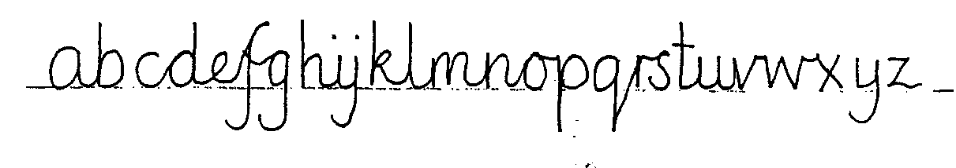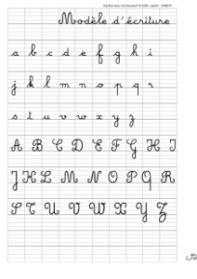

Mathematics

The Mathematics curriculum is based on Maths Targets textbook scheme and various textbooks following Education Nationale in French. We use the curricula and make links with the other curriculum subjects and areas of learning, deepening children’s understanding by providing opportunities to reinforce and enhance learning. We emphasise practical and mental maths to ensure sound understanding of underlying concepts by the time the children finish Key Stage Two.
The French curriculum in Mathematics tend to be less advanced than the British one, which give the teacher the opportunity to do often revisions of concepts pupils already approached on the English side of our curriculum. Children who are more able will be extended and sometime even work on the next level of the curriculum if they can access the materials.

Our aims in teaching Mathematics are to:
- Systematically plan opportunities for practising skills – skills such as skimming, scanning or analysing data which are taught in the context of mathematics sessions, can be further developed through purposeful use in other areas.
- Provide real experiences, context and meaning for the development of core skills in mathematics.
- Assist memory through providing opportunities for children to practise and use information in different contexts.
- Provide opportunities for application of knowledge in new contexts to involve children in higher-order thinking skills such as reasoning and problem solving.

The teaching of Mathematics is lively, engaging and involves a carefully planned blend of approaches that direct children’s learning. Children are challenged to think. Children enjoy the opportunities to practise and apply their learning. Mathematics is the combination of concepts, facts, properties, rules, patterns and processes.

The Mathematics Curriculum is broken down into seven strands.
- Using and applying Mathematics
- Counting and understanding number
- Knowing and using number facts
- Calculating
- Understanding shapes
- Measuring
- Handling data

Marking

We are committed to providing relevant and timely feedback to pupils, both orally and in writing. Marking intends to serve the purposes of valuing pupils’ learning, helping to diagnose areas for development or next steps, and evaluating how well the learning task has been understood.

Marking should aim to be a process of creating a dialogue with the learner, through which feedback can be exchanged and questions asked; where the learner is actively involved in the process.

AIMS

We aim to:
- Provide consistency and continuity in marking throughout key stages and where possible the school so that children have a clear understanding of teacher expectations
- Use the marking system as a tool for formative ongoing assessment, and to provide information
for reports.
- To identify if the child has understood the learning objective for the lesson and inform future planning.
- Increase standards by encouraging and motivating children to try their best and improve on their last piece of work, promoting higher standards and ensuring progression.
- Develop children’s self-esteem through praise and valuing their achievements
- Create a dialogue, which will aid progression and show written evidence of differentiation.
- To help other teachers when pupils move between classes.

Marking keys
- In English we have : Excellent work, well done, good job as well as
- WS with support , GR group work, PR paired work, VF verbal feedback given, I independent learning , SP check spelling
- A tick √ may indicate a section of work that has been checked, especially in maths
- Next steps and targets for next lesson.

- In French we have TB (Très bien), Bien, Bon effort

CURRICULUM

Our curriculum places the personalised learning experience of our pupils at its heart. Our small class sizes allow every child to gain the individual attention and support of excellent teachers.
The primary school offers a balanced curriculum taught by a range of specialist teachers. The pupils are taught in their form base by their class teacher in subjects such as English/French literacy and Mathematics. They will also be timetabled in different rooms across the school or outside the campus to be taught by a subject specific teacher for music, Latin, dance and sports.
The pupils in Year 1 to Year 6 follow a tailored programme, mapping both British National Curriculum 2014 and Programme de l’Education Nationale in the following subjects:
Numeracy
English and French Literacy
History
Geography
PHSEE
Latin (from Year 3)
Art
Design and Technology (club)
Science
ICT (club and in class)
Drama
Music
PE and Games

Citizenship and British values
At LPEBL we uphold and teach pupils about British Values which are defined as:
• mutual respect
• rule of law
• democracy
• individual liberty
• tolerance of those of different faiths and beliefs
We actively promote “Our” values through ensuring that our curriculum planning and delivery includes suitable opportunities for exploring these values.

Safe Guarding and Child Protection
As a school, La Petite Ecole Bilingue believes in supporting all aspects of children and young people’s development and learning, and keeping children safe.
We understand that emotional and social aspects of learning create a foundation for all academic learning. If a child has not been supported to understand, express and resolve their feelings, they may not have the ability to share with other children, resolve the small conflicts that arise in day-to-day classroom life, or concentrate on learning. Their frustrations may cause a range of antisocial, disruptive, overly compliant or withdrawn behaviour.
All staff will work to ensure that:
- Children and young people feel listened to, valued and respected
- Staff are aware of indicators of abuse and know how to share their concerns appropriately
- All paid and any volunteers are subject to rigorous recruitment procedures
- All paid and any volunteers are given appropriate support and training
Our teachers play a crucial role in helping to identify welfare concerns, and indicators of possible abuse or neglect, at an early stage. The staff is committed to referring those concerns via the Designated Child Protection Officer, Helene Knupffer, to the appropriate organisation, normally local authority children’s social care, contributing to the assessment of a child’s needs and, where appropriate, to ongoing action to meet those needs.

Please see Safeguarding and Child Protection Policy for further information

